Col. 3:12-17 – God’s Chosen One’s, Holy and Beloved.
¹² Put on then, as God's chosen ones, holy and beloved, compassionate hearts, kindness, humility, meekness, and patience, ¹³ bearing with one another and, if one has a complaint against another, forgiving each other; as the Lord has forgiven you, so you also must forgive. ¹⁴ And above all these put on love, which binds everything together in perfect harmony. ¹⁵ And let the peace of Christ rule in your hearts, to which indeed you were called in one body. And be thankful. ¹⁶ Let the word of Christ dwell in you richly, teaching and admonishing one another in all wisdom, singing psalms and hymns and spiritual songs, with thankfulness in your hearts to God. ¹⁷ And whatever you do, in word or deed, do everything in the name of the Lord Jesus, giving thanks to God the Father through him.
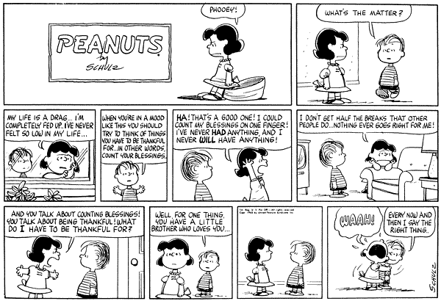

As we continue through Colossians, The Colossians faced trials that we ourselves can encounter. It is hard at times to remember that we are “God’s chosen ones, holy (sacred to Him and set apart), and beloved.” Instead, we feel much as many others do – without blessings, unloved, or unappreciated. Yet, as God encouraged the Colossians, we should apply that encouragement to our lives as well. We have “put off” the “anger, wrath, and malice of our lives;” putting to death “what is earthly in us (Col. 3:7, 5),” and taken instead a “heavenly” focus (seeking the things above). Those things are characterized by what we “put on:” mercy, kindness, humility, gentleness, patience, forgiveness (as Christ gave us), and most importantly love. Love that has been directed towards us by Christ, we have the ability to direct that love towards others and become united in Christ. There are times when we forget that love, and in doing so, we do not have peace (here the word does not reference a cessation of hostility, but instead brings out the concept of tranquility in our lives). Our lives become tumultuous when the Love of Christ does not bind us, when Christ does not rule us, and His word does not always dwell in us. Instead, ¹⁶ Let the word of Christ dwell in you richly, teaching and admonishing one another in all wisdom, singing psalms and hymns and spiritual songs, with thankfulness in your hearts to God. ¹⁷ And whatever you do, in word or deed, do everything in the name of the Lord Jesus, giving thanks to God the Father through him. – J.S.
J

